DSA0501 - Query Processing

Q1: Select the Distinct Department IDs

import pandas as pd

df = pd.read_csv("C:/Users/Lenovo/OneDrive/Desktop/QUERY PROCESSING/departments.csv")

print("Department Data:")
print(df)

print("\nDistinct Department IDs:")
print(df["DEPARTMENT_ID"].unique())

Output:
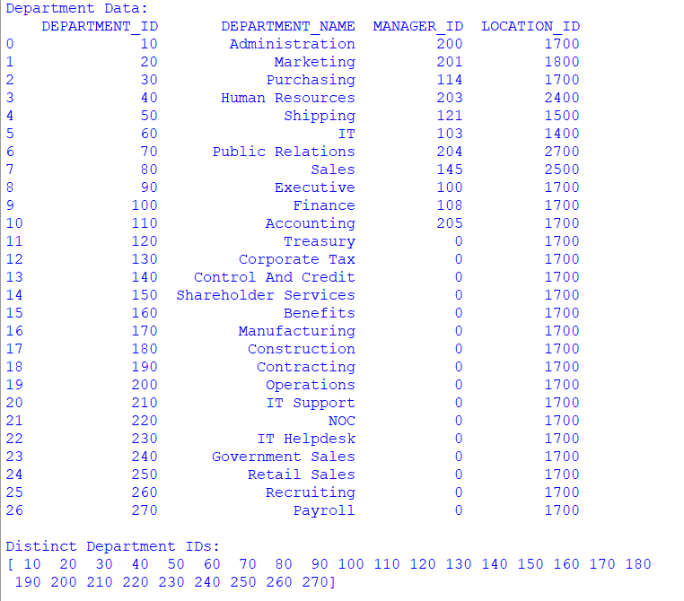

Q2: Display the IDs of employees who have done two or more jobs in the past

import pandas as pd

df = pd.read_csv("C:/Users/Lenovo/OneDrive/Desktop/QUERY PROCESSING/job_history.csv")

print("Job History:")
print(df)

job_count = df.groupby("EMPLOYEE_ID").size()

result = job_count[job_count >= 2]

print("\nEmployees who have done two or more jobs:")
print(result.index.tolist())

Output:
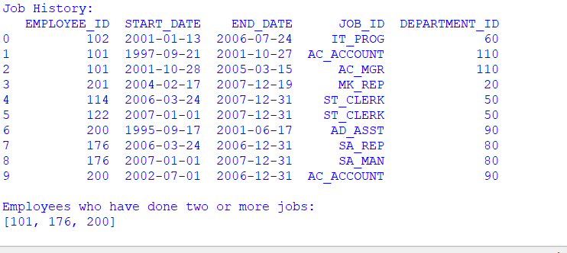

Q3: Display the details of jobs in descending order of Job Title

import pandas as pd

df = pd.read_csv("C:/Users/Lenovo/OneDrive/Desktop/QUERY PROCESSING/jobs.csv")

print("Job Details:")
print(df)

sorted_df = df.sort_values(by="JOB_TITLE", ascending=False)

print("\nJobs in Descending Order of Job Title:")
print(sorted_df)

Output:
